THESIS

Title of the thesis
Possible sub-title

Firstname Lastname
[If there are several authors, list each on a separate line]

Name and scope of the Degree Programme [see the instructions on the summary page]
(xxx credits)

[Date of submission for evaluation]
mm/yyyy [e.g. 5/2025]

Abstract
HUMAK University of Applied Sciences
[Name of the Degree Programme]
You can find the English name of the degree programme in the English-language transcript (available in the same document as the Finnish-language transcript) under the “Programme” section. Add the following words after the English name (separated by a comma): Bachelor’s Degree.

Author(s): [remove the “s” if there is only one author]
Title:
Number of pages: xx, with xx pages of appendices
Commissioned by:

Write your abstract here. It should fit on one page. The abstract serves as a summary of the contents of your thesis. It discusses the main points of all the main chapters in your thesis, in the order in which they have been presented. The language of the abstract is different from the main text of the thesis – use a passive tone and write in the past tense: “Customer opinions on the service were examined through surveys and interviews.”

However, use the present tense when discussing any general issues that were in force before and/or after the completion of the thesis, e.g.: “Robotics reduces the number of manual labour jobs” or “The results show that participation in cultural events is primarily hindered by a lack of like-minded participants.”

Your abstract should not include any sources, tables, charts, or bulleted lists. Remember to also avoid any italics, bolding, or other highlighting methods.

The easiest way to achieve the right style is to summarise the contents of your thesis in the way that a reporter would for a newspaper. Remember to avoid any promotional or sensational language.

Use your abstract to summarise and describe the main points of each main chapter. Remember to also explain the main points of your development proposals or other output.

After the abstract, add the keywords that best describe your work. Keywords are nouns that are listed as single words or word combinations.

Keywords: [Include 3–7 keywords that best describe the contents of your work.]

Contents
1 Introduction 3
2 Second main chapter 5
2.1 First subchapter 5
2.2 Second subchapter 6
3 Third main chapter 10
Sources 12
Appendices 13

(DELETE THE INSTRUCTIONS BELOW FROM YOUR FINAL SUBMISSION)
To update the Table of Contents:
- Press F9 or right-click and select Update Field. Next, select Update entire table and select OK.
- The Table of Contents is updated if you have assigned the correct styles (Heading 1 / Heading 2, etc.) to your chapter and subchapter titles. If some headings are missing, check the heading definitions in the thesis template’s styles.
- The Table of Contents’ settings follow the formatting defined elsewhere in the document. If the Table of Contents’ line spacing is too wide, use the Paragraph tools on the Home tab to condense it.

Introduction
First, read the instructions below on how to use this Word template and then replace the placeholder text with your own introduction. The instructions on the Cover and Abstract pages are enclosed in square brackets. Remove these instructions and their brackets. The template’s general formatting has been predefined in this file. When using this template for your own work, check that the formatting settings have been retained throughout the document.
Chapter titles are not automatically included in the Table of Contents if they have not been assigned the correct heading styles. The settings for paragraphs and headings are defined in the Styles Pane in Word. The Styles Pane is located on the Home tab. Use it to verify that you have selected the correct style and change it if necessary. Only the heading styles defined in the template should be used in your thesis. Below is a list of the styles that should be applied to each text element.
Formatting settings:
- Margins: Top and bottom margins 2.5 cm, right 2 cm, left 3 cm.
- Text is hyphenated and aligned to the left. The right edge is left unjustified.
- Use “Normal” for the body of your text, “Heading 1” for your main chapter titles, and “Heading 2” for your subchapter titles.
- Use the “References” style for your bibliography.
- Fonts
- Main headings: Calibri Bold, 18 pt
- Subheading: Calibri Bold, 14 pt
- Body text: Calibri, 12 pt
- Line spacing: 1.5 (summary and bibliography: 1.0)
- Paragraph spacing for the body text is set to 8 pt. To start a new paragraph, press Enter once.
- Page numbering is located at the top right of the page.
- Always start your bibliography and appendices on a new page.
- Indent the second line of a bibliography entry by 5 mm.
Any direct quotations are indented and formatted with single line spacing, as shown below. Use the predefined style “Direct quotes”. If the quotation is in a language other than the main language used in the thesis, change the language setting for the quotation to the language in question.
Lorem ipsum dolor sit amet, consectetur adipisci elit, sed eiusmod tempor incidunt ut labore et dolore magna aliqua. Ut enim ad minim veniam, quis nostrud exercitation ullamco laboris nisi ut aliquid ex ea commodi consequat. Quis aute iure reprehenderit in voluptate velit esse cillum dolore eu fugiat nulla pariatur.
Page numbering has been predefined in this template. The page numbering starts from the first page of the “Introduction” chapter and is predefined throughout the template. The length of the thesis is calculated from the body text. It does not include any parts before the “Introduction” chapter, the bibliography, or any appendices. However, the same page numbering is continued throughout the bibliography and appendices.
Before submitting your thesis for final evaluation, check that the page numbering has remained in place according to these instructions. If this is not the case, use the section break function (link opens in a new tab) between the Table of Contents and the “Introduction” chapter. Select the option for starting a new section on the next page.
Always finalise your thesis with Word’s desktop app, as the template’s layouts and Table of Contents function may not work correctly in the browser version. For example, the browser version does not display any hyphenation, while the desktop version does. This can affect the page flow and even the layout of your thesis, so remember to carefully check before submitting your work. In addition, the browser version cannot be used to create a document that meets the necessary accessibility requirements (link opens in a new tab). The texts on the cover page must be written in the desktop version. Finally, check that the logo on the cover page is in place.

Second main chapter
Always start a new main chapter on a new page. Include a short introductory text under the main chapter’s title that guides the reader to the theme discussed in the main chapter. For example, you can provide a description of the methodology strategy used in your thesis under the “Methodology” chapter. There is no pre-defined length for an introductory text – the main point is that it orients your reader to the content of the main chapter and its subchapters.
Not all main chapters have to include subchapters. For example, the “Introduction” chapter does not usually include any subchapters. The title of the main chapter name cannot be the same as the title of its subchapter. Finally, check that your titles match your contents: each title must describe the contents below it.

First subchapter
If you intend to use subchapters, you should always include at least two subchapters under the main chapter. Otherwise, there is no need for any separate subchapters, and you can include the text directly under the main chapter. Sub-subchapters are rarely needed in theses. Do not use them unless you have a very specific reason and justification for it. If you feel that it is necessary to structure the text within a subchapter in a special way that differs from your body text, use the “Unnumbered subheading” style for this purpose:
Unnumbered subheading
Such reasons may include explanations of terms, development proposals, etc. Use subchapters with caution – overly short subchapters can make your text seem disjointed. The minimum rule for a subchapter is “3 x 3”, i.e. it should consist of at least three paragraphs with at least three sentences in each. Subchapter 2.1, which you are currently reading, contains three paragraphs. However, this is only the minimum, and your subchapters should preferably be longer than this. It should also be noted that you do not need to make your subchapters excessively long, as this can make your thesis difficult to read. If a subchapter seems too long, consider whether the text would be more structured if it were divided between several subchapters.
Examine the structure and logical order of your thesis. Your knowledge base must be sufficient for handling the topic at an appropriate level, but you should also avoid expanding it excessively. The methodology chapter is typically located in the middle of the thesis. Analyse your materials comprehensively and clearly. Describe your development proposals/outputs clearly and make sure that they are based on the information gained from your materials and knowledge base. If the actual output has been appended to your thesis, use the thesis to illustrate how your knowledge base and materials have affected the output’s content and form.

Second subchapter
Figures, tables, and images are effective visual tools for illustrating information. However, you must have a legitimate purpose for using these, and they must be understandable to your readers. Do not feel obliged to add images just for illustrative purposes or for adding variety.
It is not necessary to present all of your information in diagrams or tables if the same information can be relayed more concisely as text. Never use a figure, table, or image to start or end a chapter. Place any tables, figures, and images as close as possible to the part of the body text describing their contents. All visual elements are numbered so that each type has its own sequential numbering: Figure 1, Figure 2, Table 1, Table 2, etc. Add a short yet informative legend below each figure, image, and table using “Tables and figures” style.
Typical use-cases for figures include organisational and process diagrams, as well as illustrating the implementation order of the different stages of the methods used in the thesis. Images may be needed, for example, when documenting the possible operational stages of the work. Tables and diagrams, on the other hand, can be used to summarise numerical data and present your materials in a comprehensive manner. In this case, the same information is not repeated in the body text, as it can focus on interpreting the information illustrated by your visual elements.
If you create a table in your thesis document directly in Word, and it is in a regular and simple format (does not include combined cells), you do not need to include any alt text for it. However, you should set the table’s top row as its header row in the table’s settings. This way, Word can automatically create a new header row for the table in the event that it extends over several pages. However, when possible, make sure that your tables are placed in a way that they fit on a single page. For instructions on editing the header row, see this page (link opens in a new tab).
Table 1. Population of Finland, by level of education (Statistics Finland, 2024).
Population and level of education | 2022 | % | 2023 | %
Population aged 15 or older | 4,723,642 | 100 | 4,771,619 | 100
Total number of graduates | 3,530,287 | 74.7 | 3,581,780 | 75.1
Secondary level | 1,905,233 | 40.3 | 1,913,688 | 40.1
Specialist vocational education | 52,131 | 1.1 | 54,730 | 1.1
Lowest tertiary level | 409,278 | 8.7 | 403,701 | 8.5
Bachelor’s degree | 599,447 | 12.7 | 620,512 | 13.0
Master’s degree | 511,411 | 10.8 | 534,078 | 11.2
Postgraduate level | 52,787 | 1.1 | 55,071 | 1.2
No post-compulsory qualification | 1,193,355 | 25.3 | 1,189,839 | 24.9

All other visual elements must include word-wrapping and alt texts. Alt texts allow those using screen readers to understand the contents of an image. The diagram and image below include alt text. You can view them by right-clicking on the figures and selecting the “View Alt Text” option from the drop-down menu.
Good alt text is concise. However, it must contain the key information that those not using a screen reader would receive when viewing the image. In the case of a diagram, the alt text should describe not only its content but also its type and main orientation. Your alt text should not repeat the information presented in captions, as screen readers will also read these.
You do not need to follow Word’s advice on limiting your alt text to 1–2 sentences. Make your alt text as long as it needs to be, but also make sure that it is as concise as possible. You must also remember to wrap your figures and images, as this marks their location in your text and makes it easier for screen readers to find them. For more information on wrapping and alt text, see the Writing a good alternative text and Adding an alternative text to a picture sections in the Accessibility Guide (link opens in a new tab). 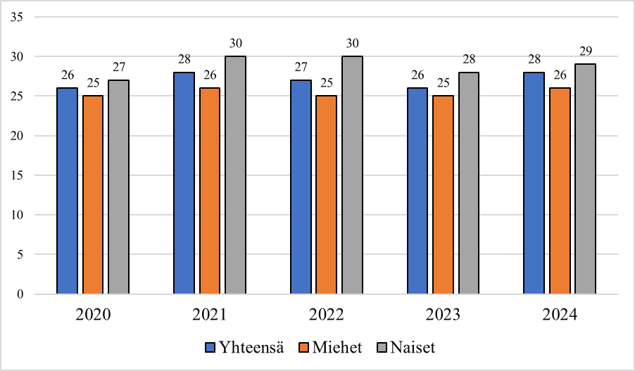
Figure 1. Studied online in the past three months to complete a course, % of the population (Statistics Finland, 2024).

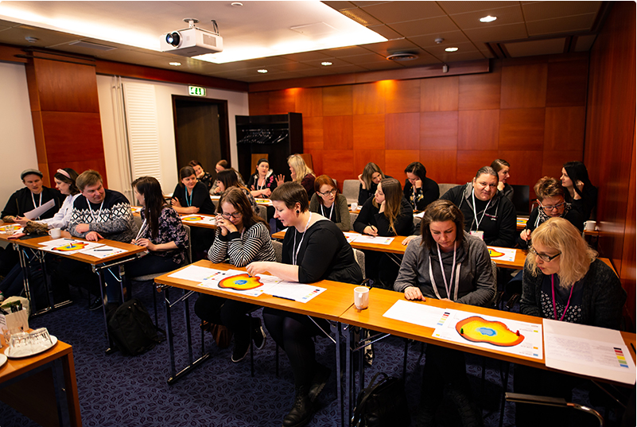
Photo 1: During the workshop, the participants used the HumaKAS platform to actively discuss the issues affecting the well-being at work of outreach youth workers. Photo: Aapo Rainio.

When using data visualisations, you should always examine your thesis as a whole and consider the best contents and formats in advance. For example, if your body text provides important numerical information about a diagram, this should be taken into account in its alt text. In this case, your alt text can focus on the information that can be quickly perceived from the diagram. However, if e.g. a diagram or figure contains a great deal of numerical information and variables, it is often more appropriate to write a separate and more detailed description of it and append it to your thesis. In this case, the alt text can explain where this description can be found. The same applies to e.g. any infographics that contain an extensive amount of numerical information presented in numerous ways.

Third main chapter
Before submitting your thesis, verify that it is a complete and fully accessible document and in the correct file format. Your appendices must also be accessible. For example, if you wish to include a survey template created in Webropol, paste and edit it in Word as part of your thesis, and replace any answer fields with bullet points. When a document is accessible as a Word file, it is also accessible as PDF/a file.
You can use Word to check the accessibility of your text. Select File > Info. The “Check for Issues” button appears. Select it and then select “Check accessibility” from the drop-down menu. Word will then inform you if your text has any accessibility issues. You may not be able to fix every small issue, in which case you can leave them as-is. For example, your cover page will inevitably contain extra spaces due to its layout. On the other hand, Word may not be able to detect every problem. For example, Word automatically generates alt texts for photos or shapes added using its Shapes tool. In most cases, these alt texts are not sensible or useful. If you are using the Shapes tool in Word, convert the shape into a separate image, import it into your text as an image, and then write an alt text that actually describes its contents.
Use Word’s settings to check that your document’s language has been set correctly. This includes any abstracts in other languages. You can adjust the language settings in Word’s settings under the Language section (Language Check). If your text contains parts (e.g. quotations) in different languages, remember to specify the correct language for each part.
Theseus requires that thesis files be named Lastname_Firstname, and we recommend using this naming format from the start. If there are two or more authors, name your work after your last names, i.e. Lastname_Lastname. In addition to a file name, your thesis must also be given a title. This is done at the point when you save your thesis in File > Details > Properties: Title. For example, your title can be: Lastname Firstname thesis, followed by the name of your thesis (if it is not very long). If the title is long, include only its main title.
Finally, save your thesis as a PDF/a file. This is important, as most popular screen readers can easily read this file format. Uploading your thesis to Theseus requires that your document includes alt texts and has been saved as a PDF/a file. Your thesis supervisor checks that your thesis is in the required format before giving you permission to upload it to Theseus. Instructions for converting to PDF/a file are available in the Thesis Accessibility Requirements guide (link opens in a new tab).

References
List your sources here in alphabetical order, following the referencing guidelines you have been given.
To format the reference list, use the style "References" from the Styles menu in Word. It is currently in use in this example.

Appendices
If you have any appendices, include them here. Start each appendix on a new page and use the heading styles for references and appendices. Number your appendices. If your appendices contain any pictures or shapes, remember to add the necessary alt texts.

